JAVA/j2EE & SOA

Project 1

Problem Statement

Project 1

## Problem Statement

Table of Contents

User login screen 1

Main Menu Display 2

Account Creation Screen 3

Transactions 4

Display statement 5

Authorize credit card transactions 6

# User login screen

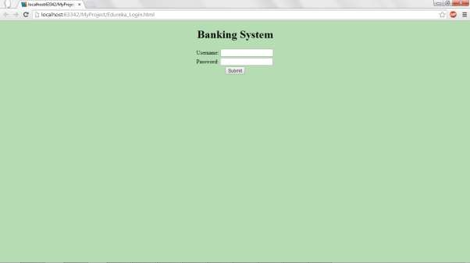

In this screen, user enters the user id and password. Entered user id and password has to be verified from the table user_pass. If the entered user is right then account creation screen is displayed else the message invalid user id / password is displayed to the user.

# Main Menu Display

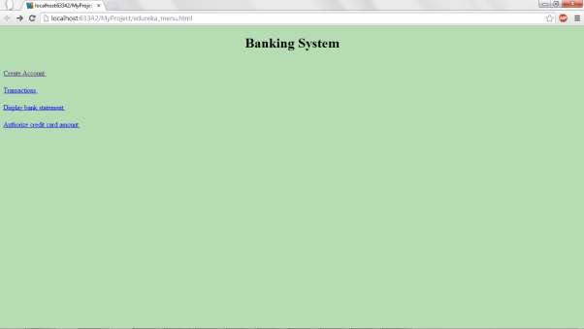If the user enteres valid user id and password then this (Main Menu screen) will be displayed. Based on the user's choice corresponding action is taken.

# Account Creation Screen

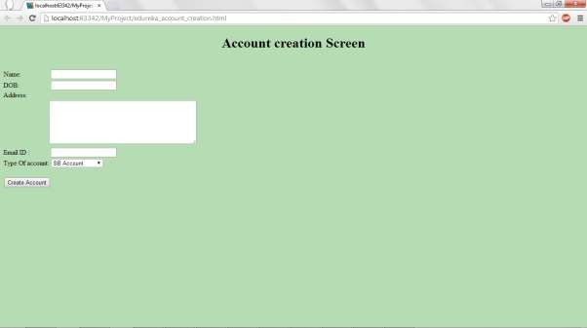

In the main menu screen, when the user selects account creation then this screen will be displayed.

User will enter the data in this screen and click on the create account button. With this, entered data will be entered into the table account_details. After performing this

operation, user will be shown the appropriate message as “Account created successfully” or “User Account is not created”.

# Transactions

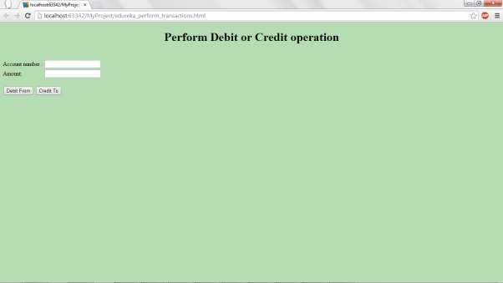

From the main menu, when the user clicks on Transactions, this screen will be displayed. Account number and the amount to be transferred will be entered by the user.

If the user clicks on Debit From, the given amount will be debited from the specified account to the logged in user's account. If the chosen option is “Credit To” then from the logged in user's account specified amount will be transferred to the given account number.

# Display statement

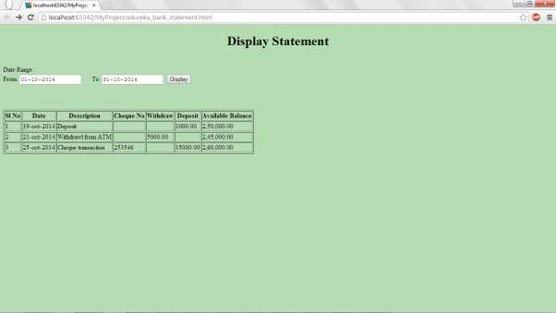

When the user selects Display statement from the main menu, this screen will be displayed. User enters the date range and clicks on display button.

With the specified date range logged in user's transactions are displayed in the given format.

# Authorize Credit Card Transactions

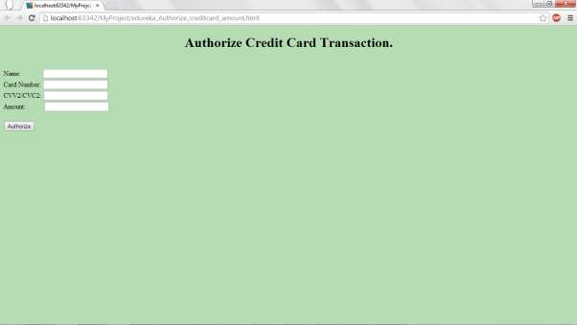

When the user clicks on authorize credit card amount on main menu then this screen will be displayed.

User will enter all the details and will click on “Authorize”. Check the validity of the card from the table credit_card. If the card is present in the table and the transaction amount i s less than 1 lakh then approve the transaction. If not reject the transaction. Message approved or rejected should to be displayed to the user accordingly.